Local docker deployment
URL - Diabetes Prediction API - Swagger UI
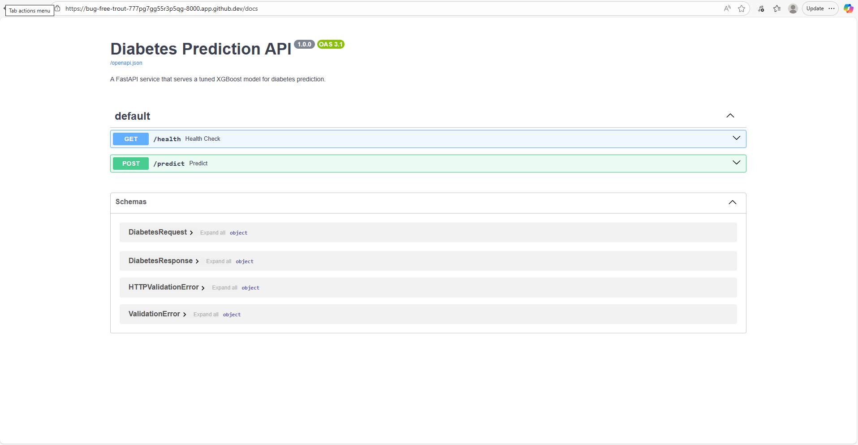

Azure Container deployment
URL - Diabetes Prediction API - Swagger UI
https://diabetes-api.mangoplant-3895156e.westeurope.azurecontainerapps.io/openapi.json

OPENAPI JSON
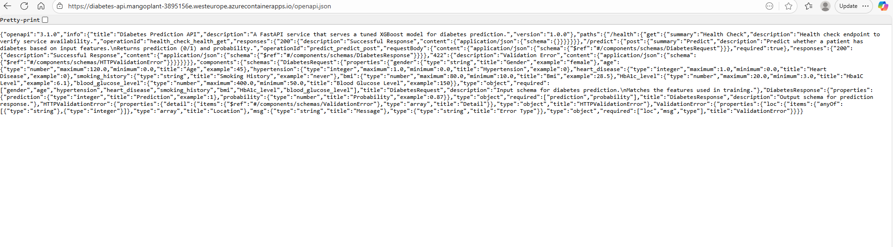

Health Check Endpoint

https://diabetes-api.mangoplant-3895156e.westeurope.azurecontainerapps.io/health
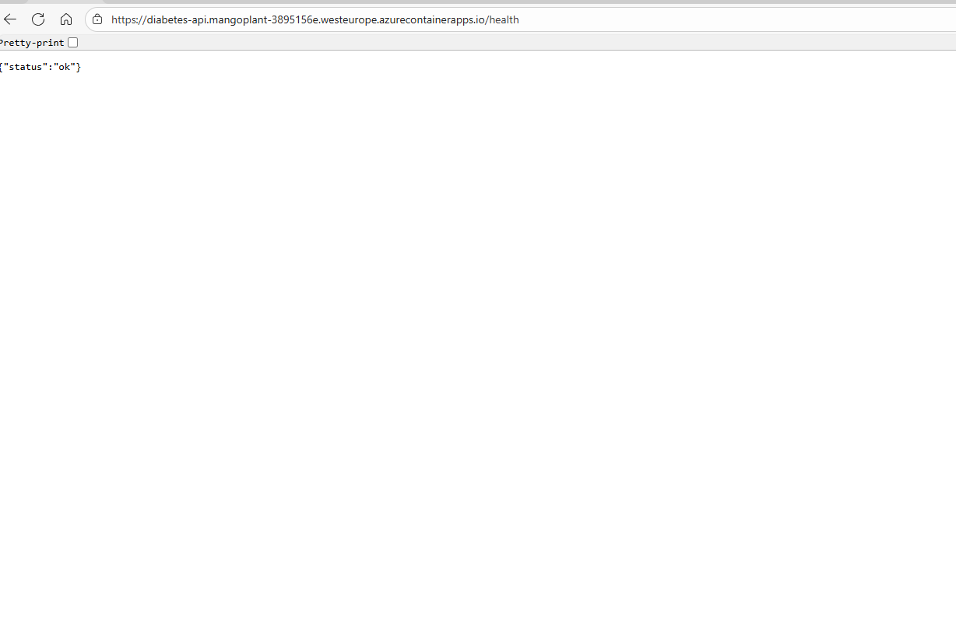

request payload
curl -X POST https://diabetes-api.mangoplant-3895156e.westeurope.azurecontainerapps.io/predict -H "Content-Type: application/json" -d '{
"gender": "female",
"age": 45,
"hypertension": 0,
"heart_disease": 0,
"smoking_history": "never",
"bmi": 28.5,
"HbA1c_level": 5.9,
"blood_glucose_level": 120
}'

{"prediction":0,"probability":0.00012600391346495599}

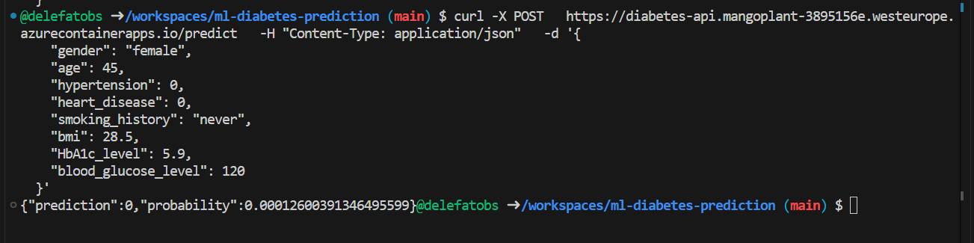

curl -X POST https://diabetes-api.mangoplant-3895156e.westeurope.azurecontainerapps.io/predict -H "Content-Type: application/json" -d '{
"gender": "female",
"age": 55,
"hypertension": 1,
"heart_disease": 1,
"smoking_history": "current",
"bmi": 38.2,
"HbA1c_level": 9.4,
"blood_glucose_level": 240
}'
{"prediction":1,"probability":0.9999772310256958}

